**Minnesota Agricultural Education**

**Internship Application**

Summer 2026

Minnesota will once again be hiring Agricultural Education Interns in 2026. The purpose of the Agricultural Education Internship is to spark an interest in current collegiate students to consider entering the teaching profession and to provide Agricultural Education students with hands-on experience in this exciting career. The internship will focus on summer programing, such as Supervised Agricultural Experience (SAE) visits, county fairs, FFA leadership activities, and additional professional development opportunities.

The internship may begin as soon as May 11, 2026 and end as late as August 14, 2026; however, exact dates of the internship are negotiable. Interns will work approximately 320 hours over the summer (no more than 40 hours/week). One week of the summer will be spent at the Minnesota Association of Agricultural Educators (MAAE) summer conference, providing opportunities for professional development and networking. The conference will be held in St. Cloud, MN from July 7-July 10, 2026.

The internship is intended for Agricultural Education majors, however, students in other majors who are interested in pursuing teacher licensure will also be considered. Current sophomores, juniors, seniors (who will complete student teaching in Fall 2026), and initial licensure graduate students from any institution should apply; however, priority will be given to those with the intent to teach in Minnesota. Any offer of employment is contingent upon the successful completion of a background check. Our presumption is that prospective employees are eligible to work here.

Interns will be University of Minnesota employees and compensated with a salary of $15.25/hour. Conference lodging, registration, and MAAE membership dues will be provided for the intern. Transportation and housing are the intern’s responsibility.

Minimum Qualifications:

* Candidate must be a current sophomore, junior or a senior (who will complete student teaching in Fall 2026). Initial licensure graduate students will also be considered. Candidate should not have graduated, or student taught prior to the start of the internship.
* Candidate should be an Agricultural Education major or have the intent to pursue teacher licensure.
* Candidates may be from any institution; however, priority will be given to those with the intent to teach in Minnesota.
* Candidate must be self-motivated, ambitious, and possess a strong desire to learn.
* Candidate must work well with youth and adults. The individual should be a strong communicator.
* Candidate must have a valid driver’s license and reliable transportation.

Internship Credits

Individual study credits may be available through your college or university. Please contact your institution to see if this internship will qualify for credit.

Application Process:

Candidates must submit an application online and provide a letter of interest, resume, and responses to essay questions, by **Monday, November 17, 2025**. The selection committee will review applications and select individuals for interviews. Please [submit online](https://hr.umn.edu/Jobs/Find-Job) at one of the following postings based on university affiliation (use the job ID in the search bar):

-Student Worker (University of Minnesota Twin Cities & Crookston students) Job opening ID - 370598

-Temporary/Casual (non-University of Minnesota students) Job opening ID - 370601

For more information or to request an accommodation during the application process, please contact Kari Schwab at opdah012@umn.edu or 612-624-6256.

*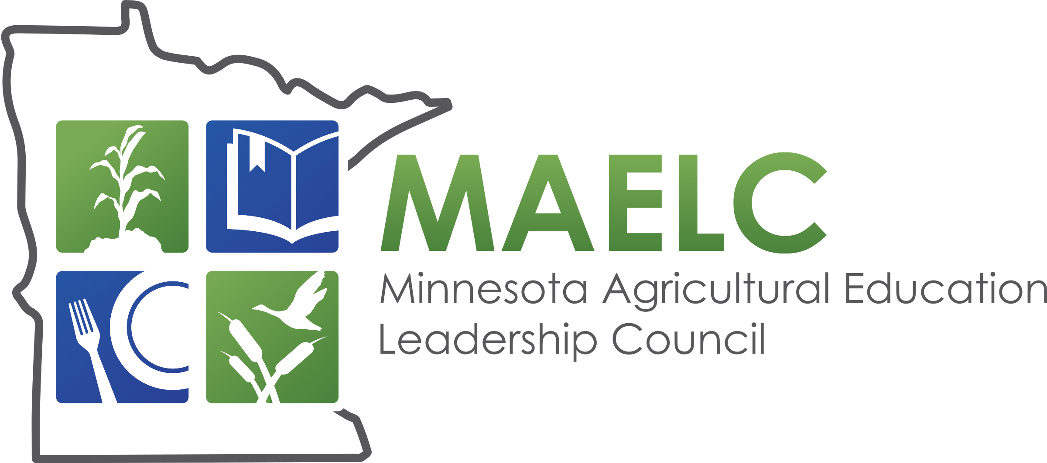***Essay Questions for Minnesota Agricultural Education Internship**

*\* When completing the online form, please attach responses to these questions along with your cover letter and resume (separate files will be uploaded for each).*

**Please include responses to the following essay questions in your application:**

1. Please explain your interest in becoming an agriculture teacher and your intent to teach in Minnesota.
2. Briefly share your experiences in Agricultural Education thus far as a high school and/or college student (class enrollment, Supervised Agricultural Experiences, FFA activities, community outreach, etc).
3. What do you hope to learn from this internship? Please share if there are any specific experiences you hope to gain during the summer (ex. agricultural mechanics, greenhouse management, SAE visits, classroom set-up advice) *Note – due to the timing of this internship, there are limited opportunities for classroom instruction.
4. Please indicate your top three choices for which Minnesota FFA Region (Region 1-Region 8) you would prefer to be located. A specific list of chapters within each region can be found at: <https://www.mnffa.org/chapter-directory.>
5. Please also include responses to the following: Current College Attending, Expected Graduation Year, High School(s) Attended, Agriculture Teachers (if applicable).